1. LANDING PAGE SECOND LAYER (Product Component)
   1. In the layer just under the slider we have a list of products and 2 advertisements. The advertisements consists of 2 types: one (AD #1) features a countdown and the second (AD #2) features an automatic slideshow of ads. These Advertisements also have an edit button which is available only to the admin if they wish to edit any part of the advertisement/slideshow. The product area consists of a list based on the highest percentage of discount per product (Hot Deals) as well as a list based on the most highly reviewed product (Trending Products).
   2. AD #1

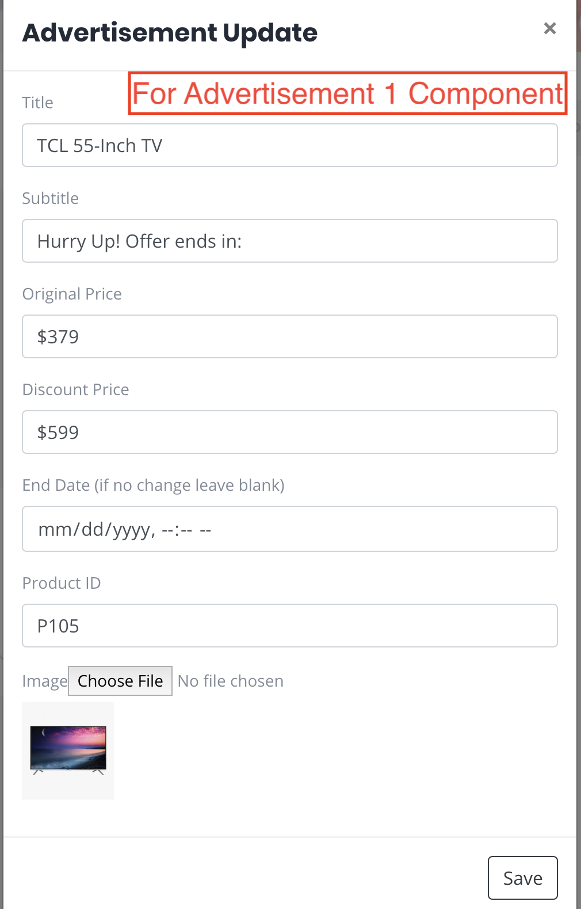

* 1. AD #2

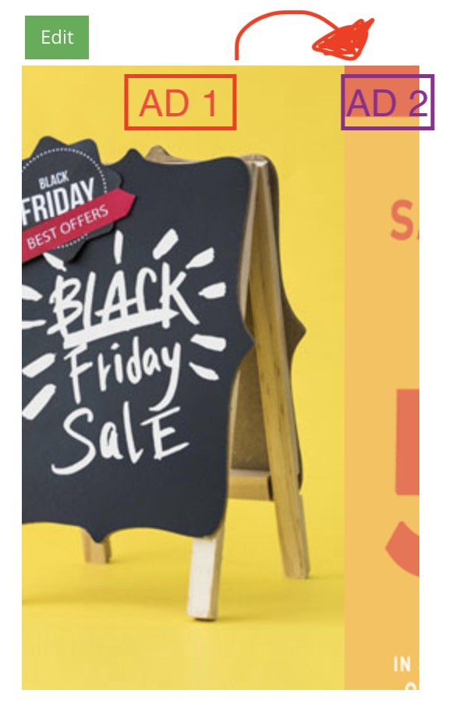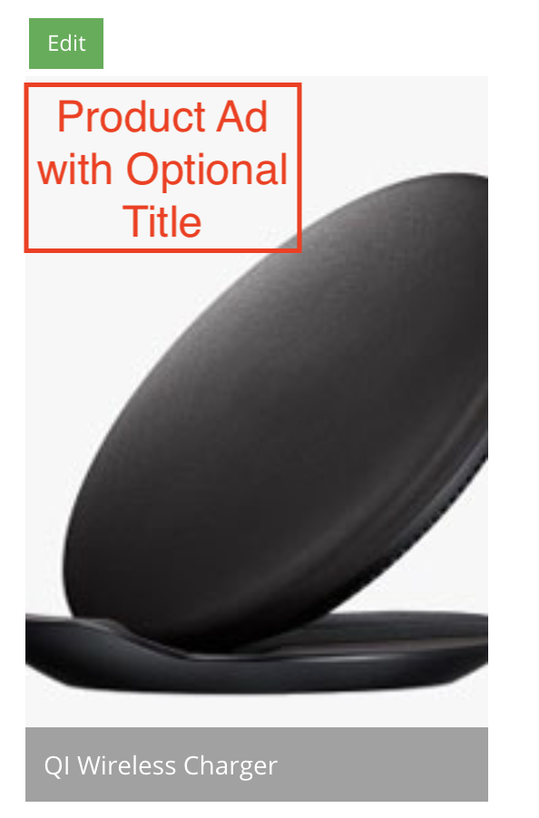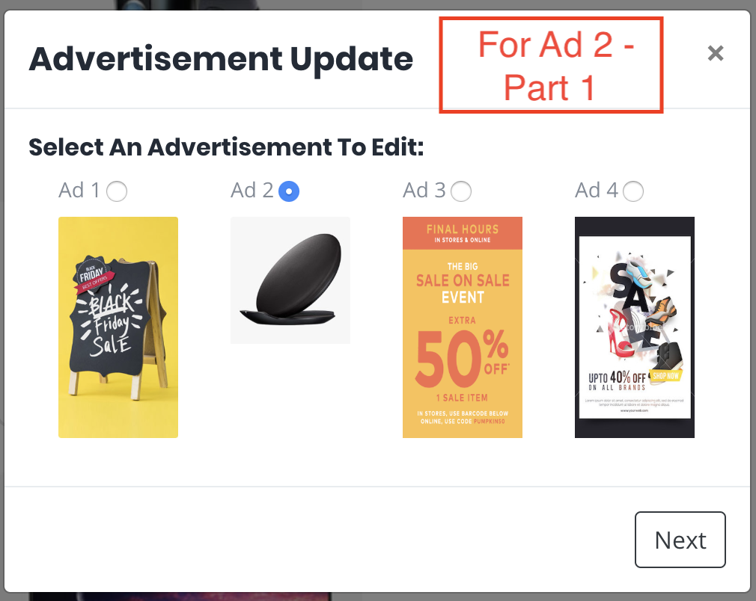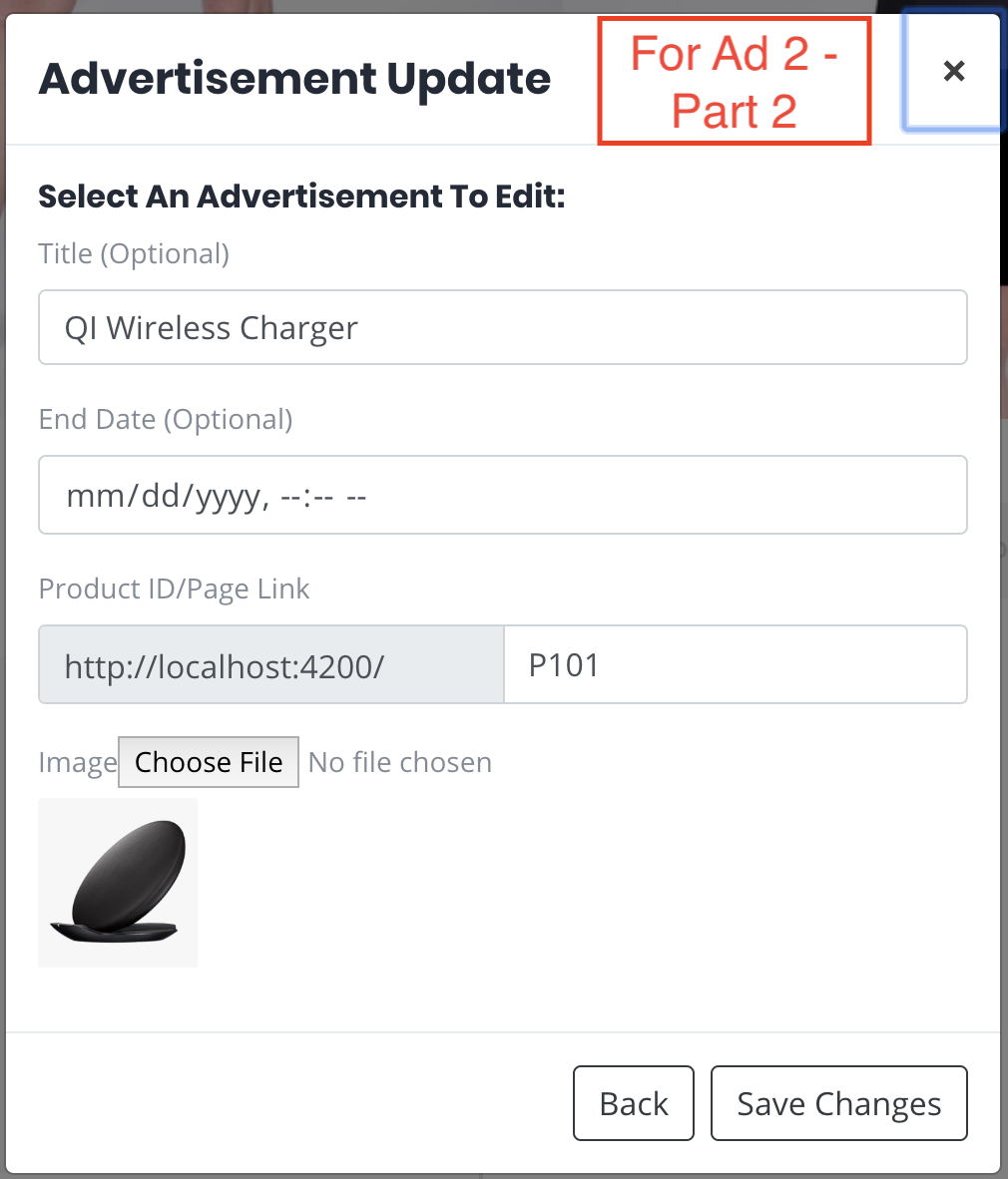

* 1. PRODUCT AREA

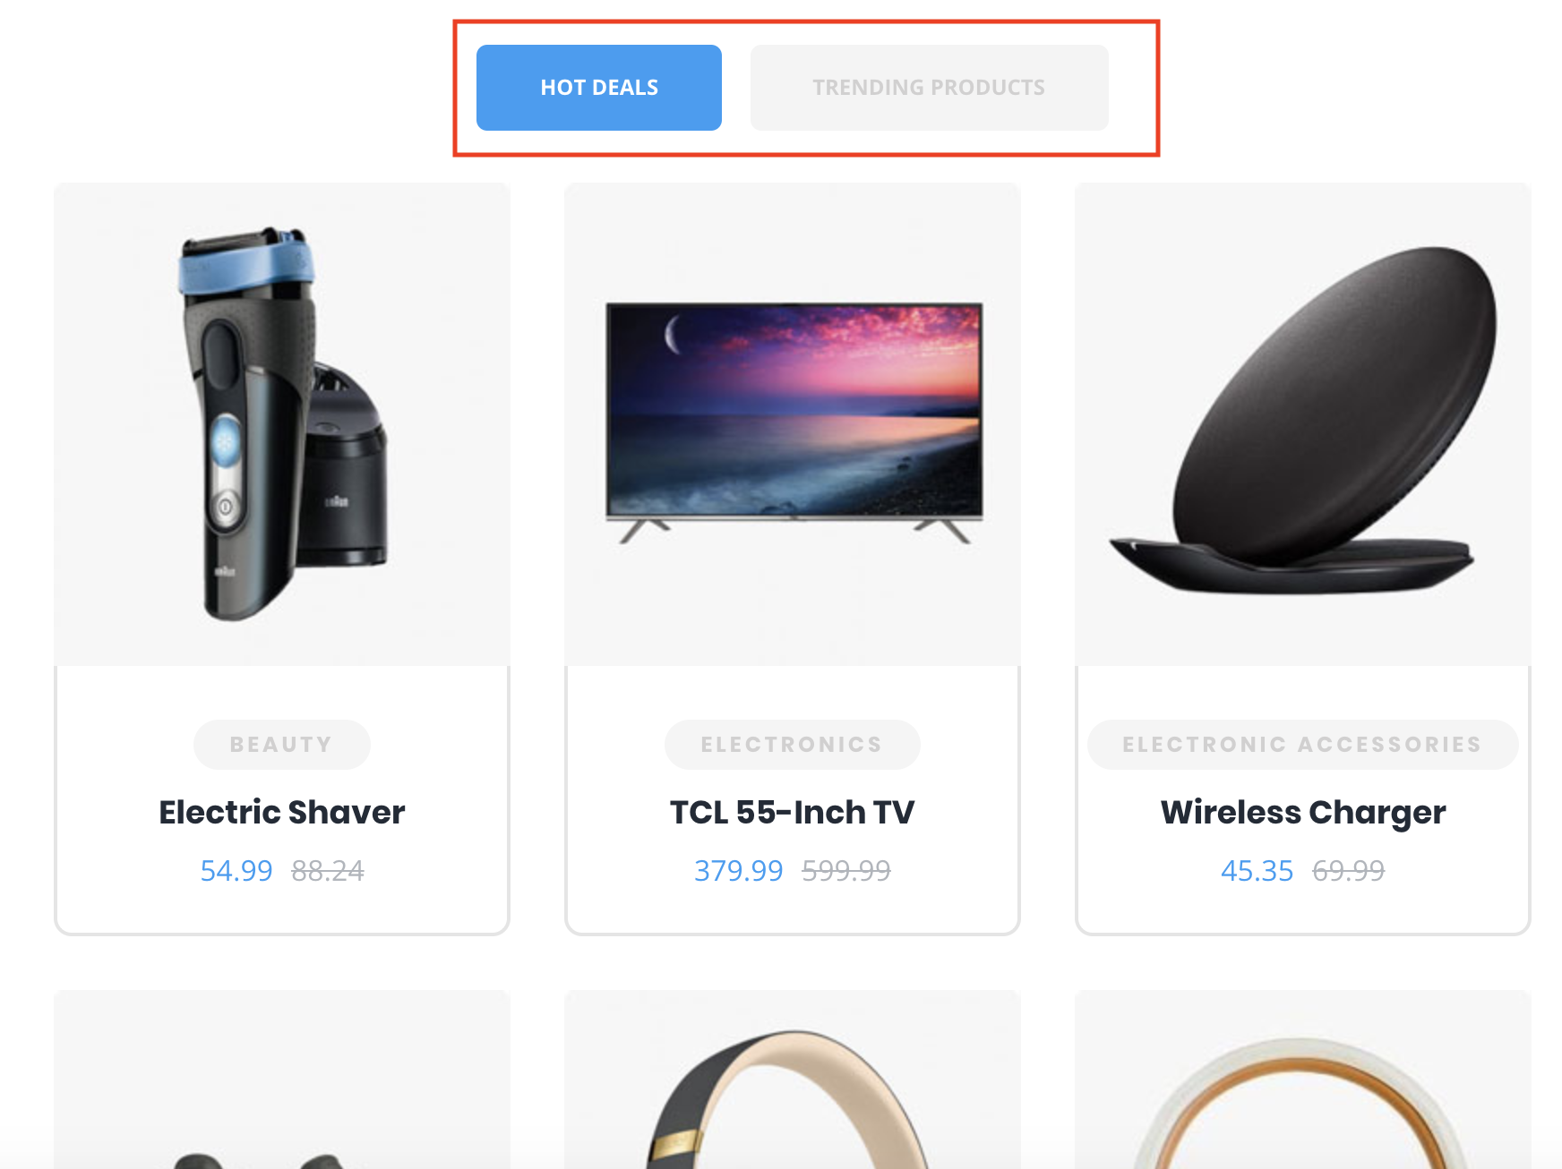

1. SPECIAL ADVERTISEMENT SECTION
   1. This layer simply consists of a photo, title, description, and header. All of which are coming from the database.
   2. 
2. LANDING PAGE VENDOR AREA
   1. This are simply lists the top vendors. The vendor details shown are their pictures, name, rating, and number of reviews/ratings. There is also a link at the bottom of this component to see the full list of vendors.
   2. VENDOR COMPONENT: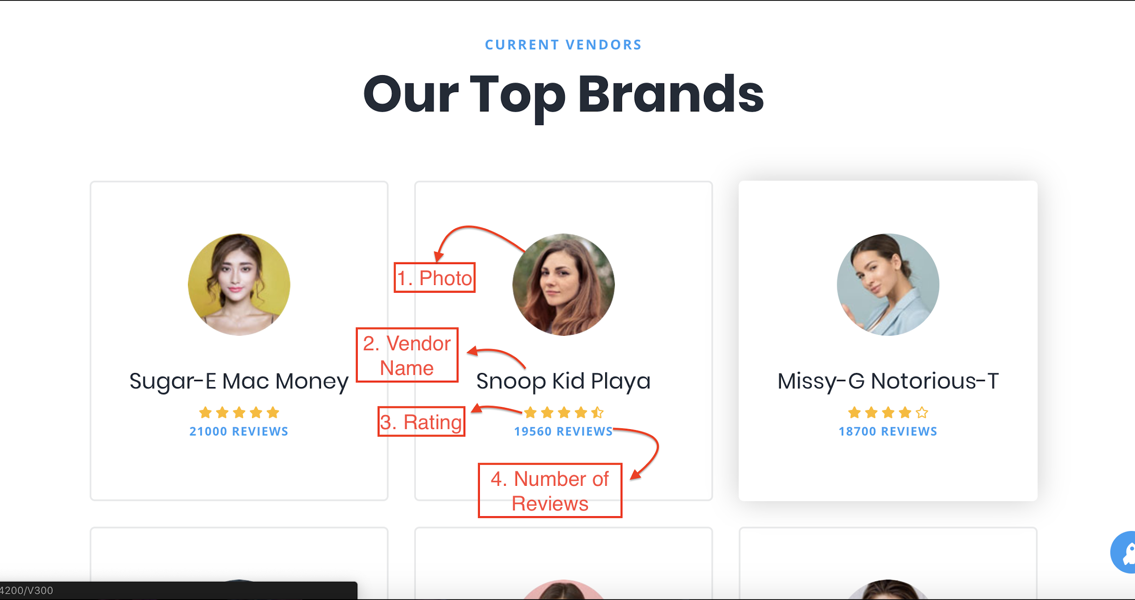
3. CHECKOUT PAGE
   1. In the checkout page,the user will be able to view the products in their cart that they are about to purchase, the subtotal, tax, and shipping price. The user is asked to input their billing details (First Name, Last Name, Company Name, Country, Street Address, Apartment Number, City, Zip Code, Phone Number, Email, \*\*NOTE: the fields which are NOT required are Company Name and Apartment Number), their payment details (Payment Type, Credit Card Number, Credit Card Type, Expiration Date, and CVV Number), as well as an optional Order Notes section. Once the user enters all the required details they will be allowed to click the button to place their order.
   2. ORDER SUMMARY

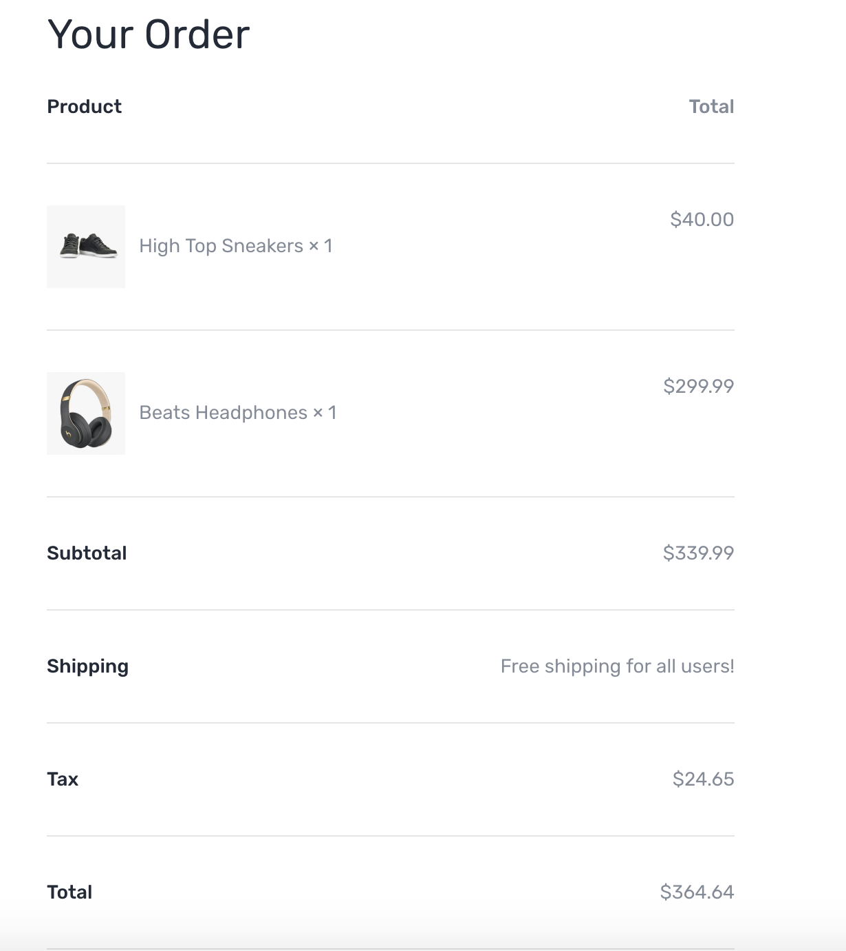

* 1. BILLING DETAILS

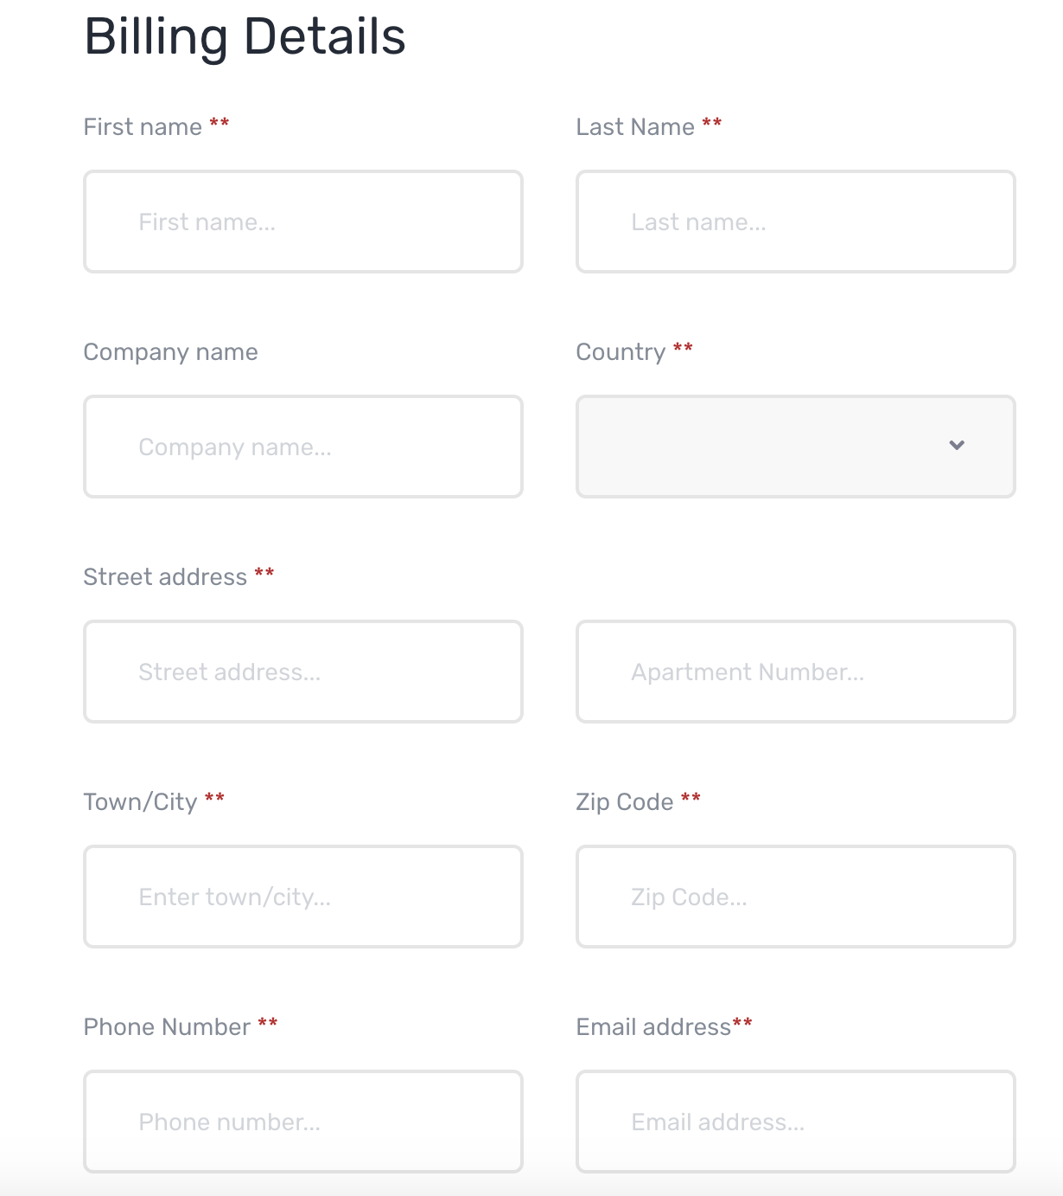

* 1. PAYMENT DETAILS

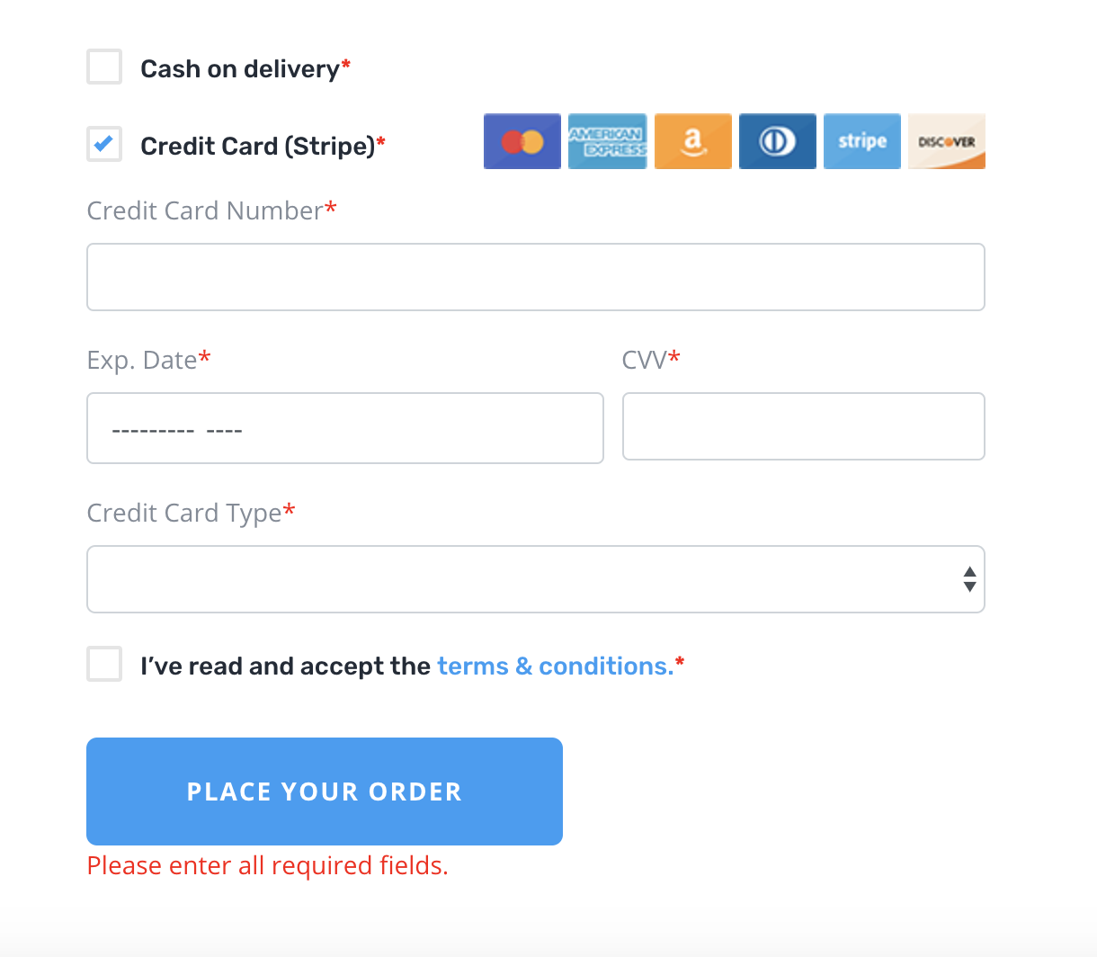

* 1. Once the user places their order they will be redirected to the order confirmation page where they will be able to view the products and quantity of products they purchased, their shipping/billing details, and other details.
  2. CONFIRMATION PAGE

